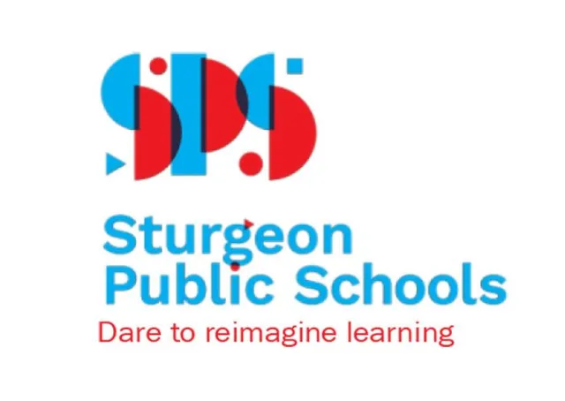
K-5 Winter Concert 2023 – AGENDA
Namao School’s Annual Winter Concert is soon approaching! Students in Kindergarten up to Grade 5D have begun rehearsing songs for their upcoming Winter Concert. Classes by grade will sing a song, Primary will combine to sing a song, and Elementary classes will combine to sing a finale song to end the show.
The message encourages us to enjoy this time of year and to celebrate the season in a variety of ways. Concerts will take place on Monday, December 11th in our Gym, at 1:15 pm (for guests who work in the evening) and 6:30 pm (for guests who work in the afternoon). The concert usually runs about an hour. For the evening concert, students have been asked to meet in their homerooms by 6:00 pm, dressed and ready to go.
All student performers should wear bright semi-formal clothing in festive colours (any of green, red, black, white, silver, gold). Please label all accessories / props and costumes - as assigned in class - and label with the student’s full name and bring them to school by December 4th.
Classes will perform selections from the following titles:
Kindergarten Classes - SANTA and Snowman Joe - (wear a santa hats if available)
1C + 1T - Hanukkah Fun (dreidels & menorahs as assigned)
2B + 2W - There’s Hope in the Air this Christmas - (as above)
3P + 3W - Kwanza Tonight (as above)
4C - Toyland Toybox (toys as assigned)
4/5R - Deck the Halls Bossa Nova (TBA)
5D - Elf on the Shelf (as above) - one assigned student in an Elf costume
Grade 1, 2 & 3 Finale - Reindeer Love to Boogie (reindeer hat - make or buy)
4C, 4/5 & 5 Finale - I Want a Hippopotamus for Christmas

If you have any questions, please contact me. Thanks for your support and I’m looking forward to seeing you there!

Wyn Humphries, B.Mus, M.Ed.
Music Teacher
Namao School
780 973 9191

