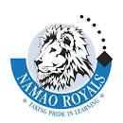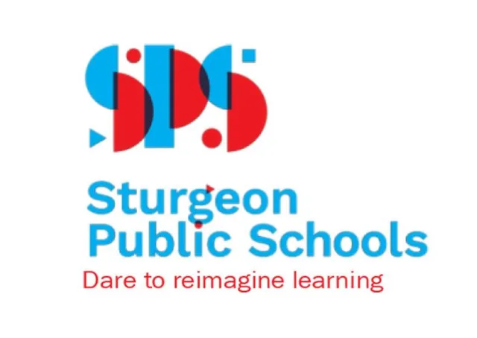
2-24400 Hwy 37
Sturgeon County, AB
T8T 0E9
780-973-9191
Winter Concert - Bands & Choir 2023 – AGENDA
Namao School’s Annual Winter Concert is approaching! It is scheduled to begin on Thursday, December 7th at 6:30 pm in our Gym. Students in 6K, 6L, Junior High Band (Beginner & Advanced Students) and Choir have been learning and rehearsing exciting music! This is a concert for students to demonstrate their musical progress for our community. Admission is free.
Before and after the Concert, Namao Music Parents Association (NAMPA) will sell Grocery Cards for instant purchase. Accepted payments are by email transfer to nampafees@gmail.com or via Square Terminal in person. Your own proceeds benefit and will be recorded for your family. Average earnings are 6% on purchased cards (Superstore, No Frills, Safeway, Sobeys).
Jr. High Band Students will meet at 6:00 pm in the Music Room and 6K and 6L will meet in their homerooms at 6:00 pm. Choir will meet at the Risers by 6:20 pm (sit in Seating Chart). Students must be dressed in white collared shirts, black bottoms and dark shoes when they arrive. Students should use the washroom and get a drink before lining up. Band students will put on ties (Junior Highs), warm-up, and then all line up by Seating Order at 6:20 pm - single file, percussion leading, back row, middle row and then the front row. Seating Charts will be posted for students to see.
The concert usually runs about an hour. Selections from these titles will be performed:
Junior High Band – Christmas Collage
Choir – Seven Feet of Snow
6K + 6L – Soundstart Tunes
Junior High Band – Not So Silent Night
Choir – Marshmallow World
K + 6L – Jolly Old St. Nicholas
Junior High Band – Winter Wonderland
Choir – Candy Cane Lane (candy cane props)
6K + 6L – Solid State
Bands & Choir – Grandma Got Run Over by a Reindeer
Noon Practices are to be scheduled: Day 1 closed, Day 3 Choir, Day 2, 4 & 5 (TBA).
At the end of the Concert, students will put their instrument and folder away carefully, rack their stand and chair, plus put away other equipment properly. Once clean up is finished, a treat will be handed out to students who have helped after the Concert. If you would like to hand out treats to students, please let me know. Contact me if you have any questions and please let me know by November 23rd if your child is unable to attend so that we can figure out seating and ensure that parts are covered. Thanks for supporting your child, and I’m looking forward to seeing many of you at our Band & Choir Winter Concert!
Wyn Humphries, B.Mus., M.Ed.
Music Teacher
Namao School
780 973 9191

